EDF

British Gas

Macquarie

Scottish Power

Lowri-Beck

Calvin

Dataserve UK

Enterprise

Siemens
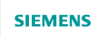
NPower

SSE

E.ON


metercorp.

