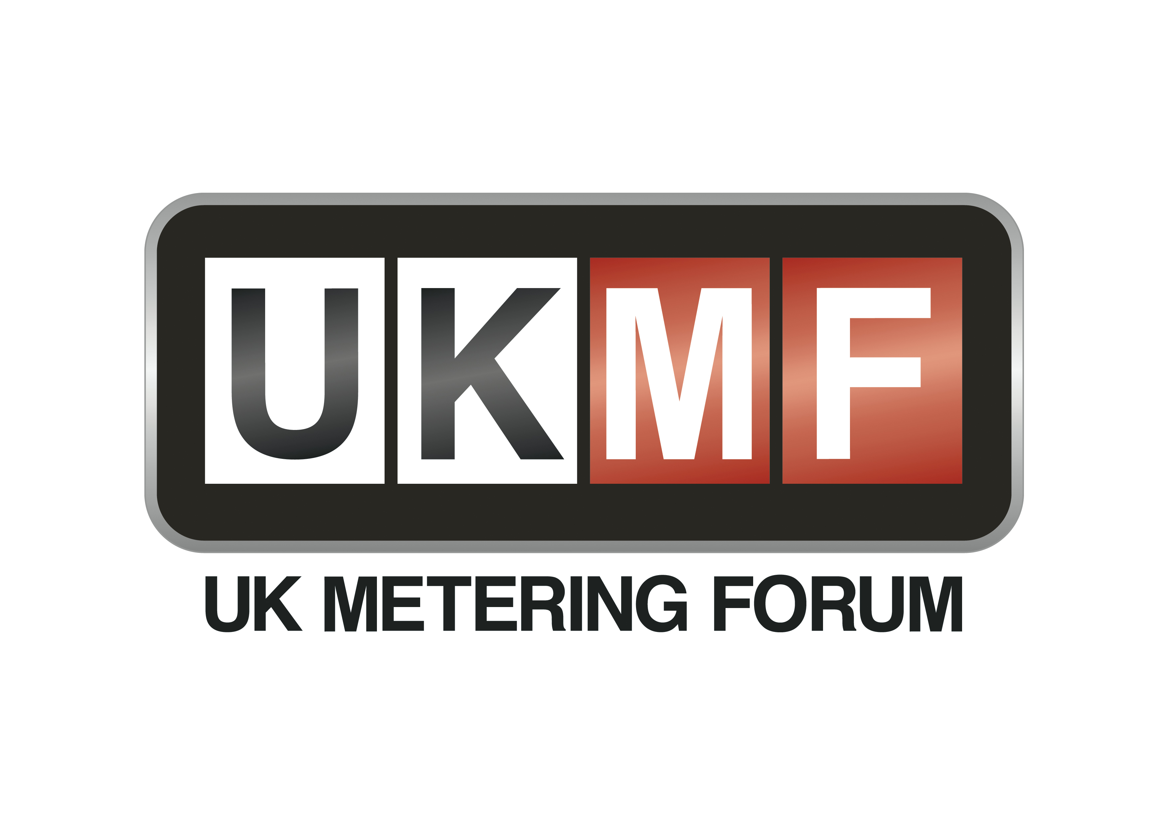

Membership application form 2026/27
UKMF was originally formed in 1997 under the auspices of the then Electricity Association. The forum is a trade association open to owners and operators of electricity and gas metering assets trading as Meter Service Providers (MSPs). It is primarily concerned with representing members interests and communicating with UK and European legal metrology and regulatory bodies, industry working groups, data communications bodies, trade associations and standards bodies on technical and political matters.
The Forum aims to:
- Provide an opportunity for the discussion of matters relating to metering with a view to represent and pursue these interests as agreed by members;
- Provide spokespersons to represent Members’ interests to relevant bodies;
- Provide opportunities for the exchange of information on technical, operational, safety or regulatory issues impacting metering business; and
- Promote or sponsor meetings, seminars, publications or other such activities as agreed by members.
The Forum is governed by a Constitution which defines the purpose of the Forum, its membership and the roles and responsibilities of its participants and representatives.

Please complete the below membership form and return to UKMF@gemserv.com to proceed with your membership application.

COMPANY DETAILS
Company Name:
Company Registration Number:
Company Registered Address:
Role in Industry:
(Please see Clause 4.1 of the Constitution)
PRIMARY CONTACT DETAILS
Name: |  | Email:
Tel: |  | Role:
SECONDARY CONTACT DETAILS
Name: |  | Email:
Tel: |  | Role:
MEMBERSHIP TYPE
Full Member
Affiliate Member
FINANCE CONTACT DETAILS
PO Number for Membership Fees:
Name: |  | Email:
Tel: |  | Address:
SIGNATORIES FOR DEED OF ACCESSION (2 DIRECTORS REQUIRED)
Director name: |  | Director email:
Director name: |  | Director email:
This Applicant hereby applies for admission to the UKMF as a Member, and undertakes to perform and be bound by the terms and conditions of the UKMF Constitution.
Signature: |  | Date:

Please return the completed form to: UKMF@gemserv.com
Your application will be processed, and membership will commence following receipt of the Membership Fee & signed deed of accession.

Full Membership is available to companies trading as Meter Service Providers (MSPs)
Affiliate Membership is available to companies providing services closely associated with the metering industry, as deemed acceptable by the majority of UKMF Full Members

